**PIZZA SALES MYSQL QUERIES**

**A. KPI’s**

**1. Total Revenue:**

select round(sum(total_price),2) as total_revenue from pizza_sales_portfolio.pizza_sales ;

***Output:***

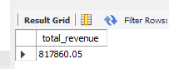

**2. Average Order Value:**

select round(sum(total_price)/count(distinct order_id),2) as avg_order_value

from pizza_sales_portfolio.pizza_sales ;

***Output:***

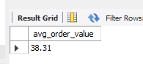

**3. Total Pizzas Sold:**

select sum(quantity) as total_pizza_sold

from pizza_sales_portfolio.pizza_sales ;

***Output:***

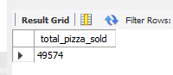

**4. Total Orders:**

select count(distinct order_id) as total_orders

from pizza_sales_portfolio.pizza_sales ;

***Output:***

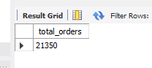

**5. Average Pizzas Per Order:**

select round(sum(quantity)/count(distinct order_id),2) as average_pizzas_per_order

from pizza_sales_portfolio.pizza_sales ;

***Output:***

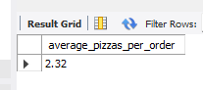

**B. Daily Trend for Total Orders:**select dayname(order_date) as order_day, count(distinct order_id) as total_orders from pizza_sales_portfolio.pizza_sales

group by dayname(order_date) order by count(distinct order_id) desc ;

***Output:***

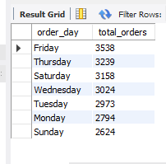

**C. Hourly Trend for Orders:**

select hour(order_time) as order_hours, count(distinct order_id) as total_orders from pizza_sales_portfolio.pizza_sales

group by hour(order_time) ;

***Output:***

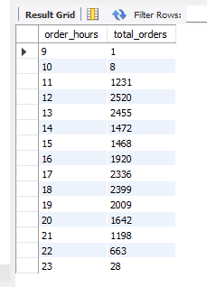

**D. % of Sales by Pizza Category:**

select pizza_category, round(sum(total_price),2) as total_sales, round(sum(total_price)*100 /

(select sum(total_price) from pizza_sales_portfolio.pizza_sales),2) as percentage_of_total_sales

from pizza_sales_portfolio.pizza_sales

group by pizza_category ;

***Output:***

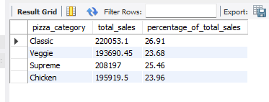

**E. % of Sales by Pizza Size:**

select pizza_size, round(sum(total_price),2) as total_revenue, round(sum(total_price)*100 /(select sum(total_price) from pizza_sales_portfolio.pizza_sales),2) as percentage_of_total_sales from pizza_sales_portfolio.pizza_sales group by pizza_size order by percentage_of_total_sales desc ;

***Output:***

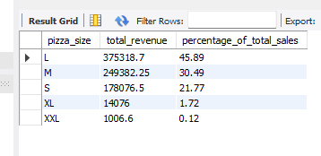

**F. Total Pizzas Sold by Pizza Category:**

select pizza_category, sum(quantity) as total_pizzas_sold from pizza_sales_portfolio.pizza_sales group by pizza_category ;

***Output:***

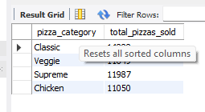

**G. Top 5 Best Sellers by Total Pizzas Sold:**

select pizza_name, sum(quantity) as total_pizzas_sold from pizza_sales_portfolio.pizza_sales group by pizza_name order by sum(quantity) desc limit 5; ***Output:***

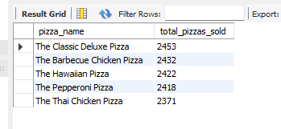

**H. Bottom 5 Best Sellers by Total Pizzas Sold:**

select pizza_name, sum(quantity) as total_pizzas_sold from pizza_sales_portfolio.pizza_sales group by pizza_name order by sum(quantity) asc limit 5; ***Output:***

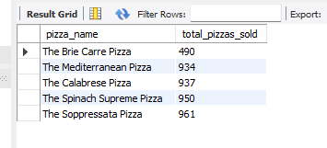

***NOTE:***

If you want to apply the Month, Quarter, Week filters to the above queries you can use WHERE clause. Follow some of below examples:

select dayname(order_date) as order_day, count(distinct order_id) as total_orders from pizza_sales_portfolio.pizza_sales where month(order_date) = 1 group by dayname(order_date) ;

*\*Here month(order_date) = 1 indicates that the output is for the month of January. month(order_date) = 4 indicates output for Month of April.*

select dayname(order_date) as order_day, count(distinct order_id) as total_orders from pizza_sales_portfolio.pizza_sales where quarter(order_date) = 1 group by dayname(order_date) ;

*\*Here quarter(order_date) = 1 indicates that the output is for the Quarter 1 and quarter(order_date) = 3 indicates output for Quarter 3.*